Go to gcp console 🡪 Click on VPC Network

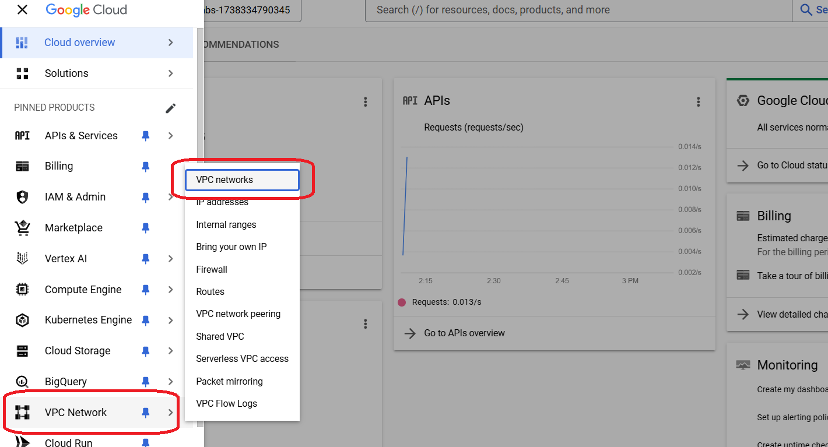

Click on Create VPC Network

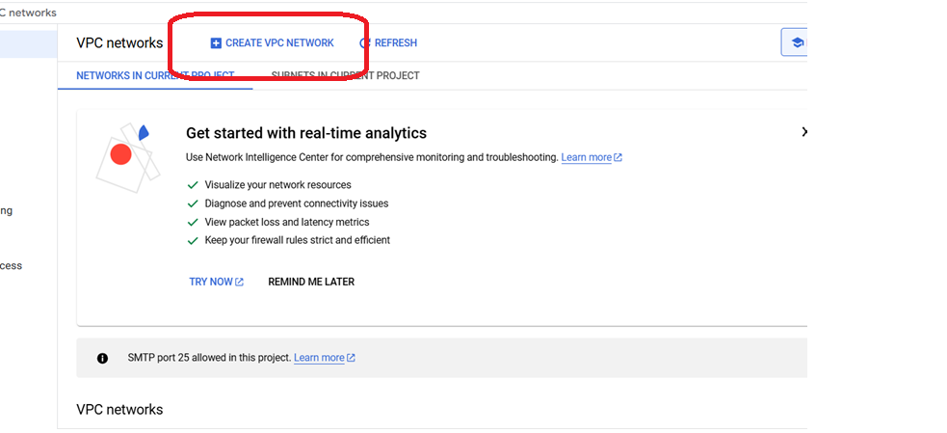

Provide VPC a name and Select subnet creation mode automatic

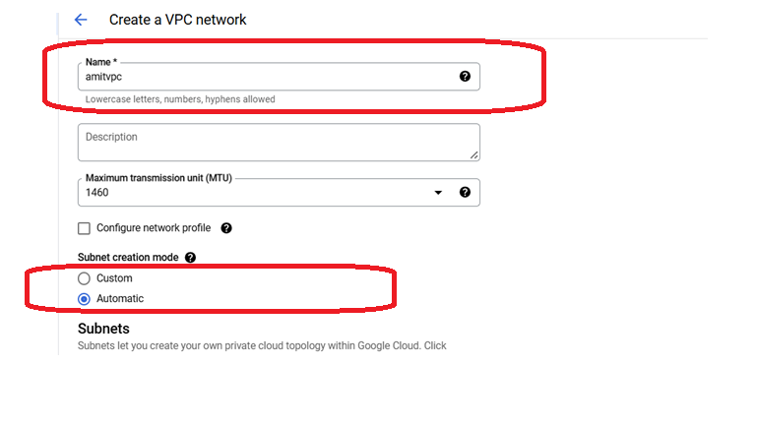

On the same page, select the firewall rules for ssh and rdp

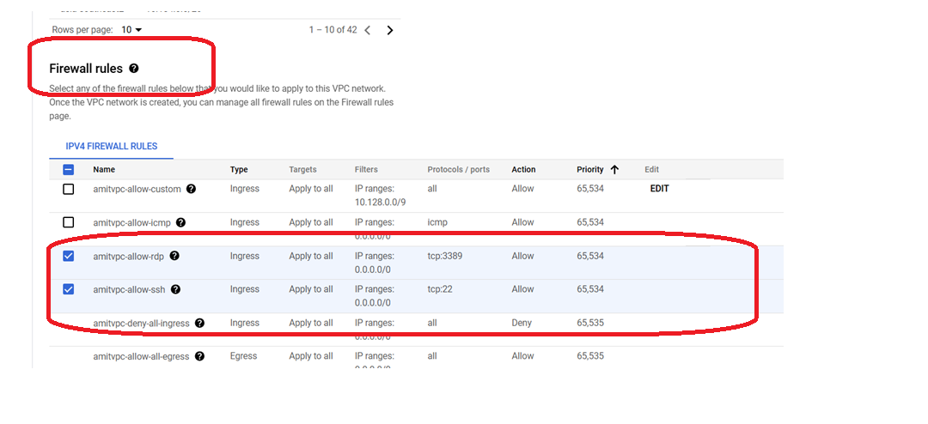

Dynamic routing keep it regional

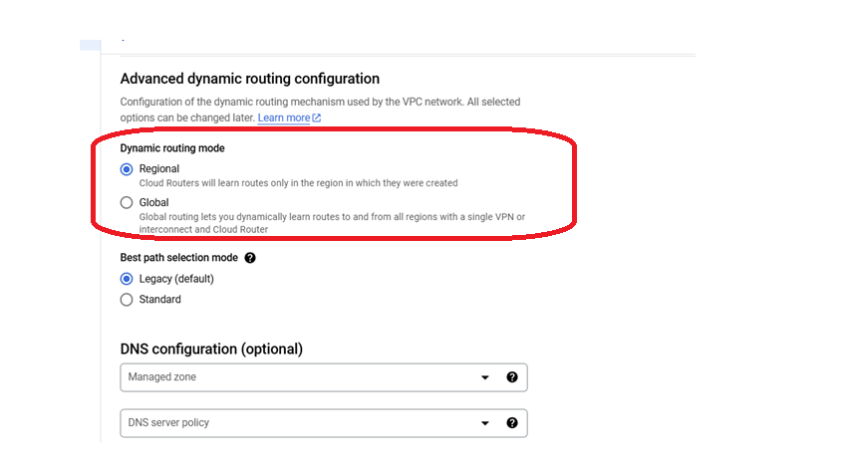

Check the equivalent command line and close it

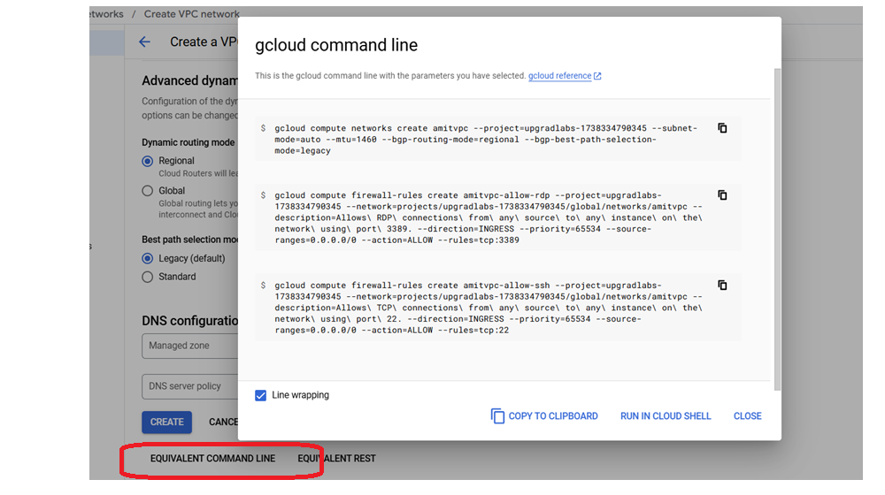

Now click on VPC and create

